Samsung 870 QVO 4TB 2.5" SATA III Internal SSD | MZ-77Q4T0

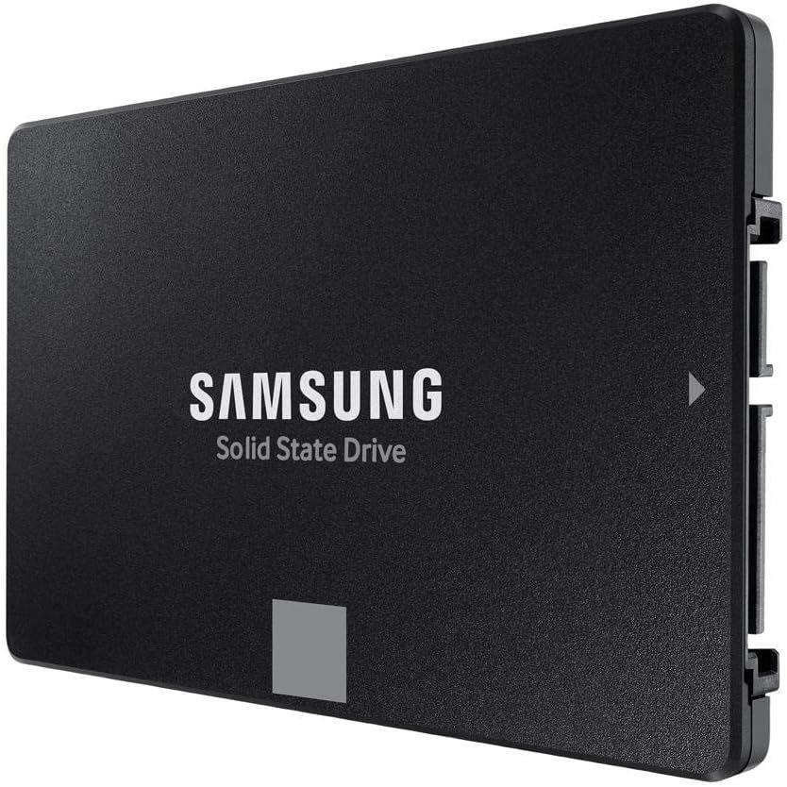

**Key Specifications:**

* **Capacity**: 4TB
* **Interface**: SATA III (6Gb/s), backward compatible with SATA II and I
* **Form Factor**: 2.5"
* **Sequential Read Speed**: Up to 560 MB/s
* **Sequential Write Speed**: Up to 530 MB/s

**Performance Features:**

* **Intelligent TurboWrite Technology**:  
  Enhances write speeds and maintains high performance for longer durations.
* **SATA III Compatibility**:  
  Delivers fast and reliable performance for a wide range of desktop and laptop systems.

**Warranty :**

* Backed by a **3-year limited warranty**, ensuring peace of mind and customer support.